Lab Report 4

Physics 261-005

Author: Edward Auttonberry

Lab Partners: Paige Meeks

Date: 4/13/18

**Objective:** The objective of the lab is to learn how a force applied on an object, the objects mass, and its acceleration are all related. We will learn how to measure the acceleration of a cart on a track being pulled by a hanging mass and compare the results to acceleration that is calculated theoretically.

**Theory:** According to Newton’s Laws, an object’s acceleration is proportional to the forces acting on that object. Newton’s Second Law states that an object of mass *M* will accelerate in the direction of a net force *Fnet*­ at a rate parallel to *Fnet*­ and inverse of *M*:

$a=\frac{F_{net}}{M}$ Eq. (1)

Given that to calculate the acceleration of an object, we need the net force acting on it; we will need to derive the direction and magnitude of the net force from the known variables. In many laboratory experiments, the force acting on an object will be dependent on a mass hanging over a pulley and connected to the object in question. When using this procedure, the net force on the hanging mass as well as that on the object must both be included in calculations. Therefore, we would find the acceleration of an object in this situation with:

$a=\frac{m*g}{\left(M+m\right)}$ Eq. (2)

Where *m* is the mass of the hanging mass and *g* is the gravitational constant at sea level on earth.

**Procedure**: Starting off, we need to make sure that the conditions are optimal for running the experiments. The track needs to be level and the sensors that we will be using need to be in working condition so that the data is somewhat consistent. After assembly of the cart and its sensors, we begin **Procedure A**.

**Procedure A**

After preparing the cart, its sensors, and the Logger-Pro interface for experimenting we perform this procedure to show the relationship between *Fnet* and *M*. The sampling period was set to 5 seconds at 100 samples per second. After starting the readings, the cart was left in it’s starting position for about one second to show the force and acceleration of an object at rest as a control to compare against. After that period, holding onto a string attached to the force sensor hook, we began moving the cart back and forth on the track at regular physical and temporal intervals. The charts produced by Logger-Pro for this period were used to compare acceleration and the force changes over time, as well as the relationship between the force and the acceleration direction in a non-functional plot.

**Procedure B**

In preliminary analysis of Procedure A, the mass of the cart was measured directly on a scale. For this procedure, instead of pulling the cart from the string manually, an inanimate weight would serve as the primary component force in the net force acting on the cart. To this end, a weight of a specific mass was attached to the string on the sensor and hung over a pulley. The weight would be let go of, causing the falling weight to pull the cart. This type of trial was repeated 6 times, each consecutive time adding more weight. The primary data collected from these trials would be the average force and acceleration of the cart over each of the trials.

Considering the volatile nature of a freely accelerating cart, to make sure we only used the data that shows the movement of the cart, we selected only a certain region of the data generated by the sensors. The beginnings of the regions selected were identified by leaving the cart motionless but with the tension of the hanging weight acting on it for about a second, and then letting the cart free afterwards. This would create a small dip in the force readings that would allow for marking the actual beginning of the trial. The end was identified by a sudden, sharp, and noisy decrease in the force and acceleration of the cart. The data contained in these selected regions would be that used to estimate the average force and acceleration of the cart for the duration of each trial.

**Data:** The data collected to measure the force and acceleration on the cart as it moves across the track in Procedure A is plotted in Figure 1. The scale is set to the time of the trial-five seconds-to given resolution to the measurements.

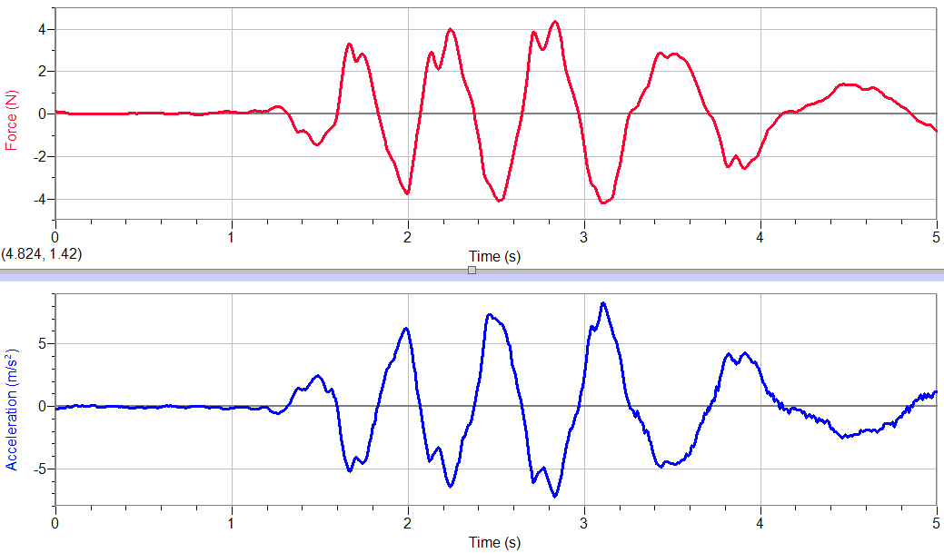

Figure 1. The force and acceleration acting on the cart as it is dragged back and forth across the track. The cart was held still for about the first 1.1 seconds.

The extrema in the plot of the force over time and the plot of the acceleration over time line up, and whenever there is a change in the force graph, there is a corresponding change of a proportional magnitude in the acceleration graph.

The data in figure one was replotted to set the force against the acceleration, which is shown in Figure 2.

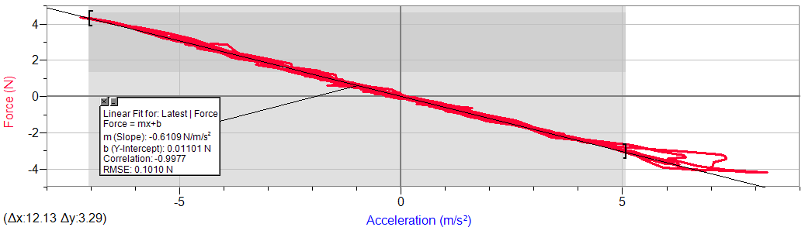

Figure 2. The data showing the relationship between the force on and the acceleration of the cart. A line is added to show a somewhat linear relationship.

As the reading for the force on the cart increases, the acceleration reading decreases at a proportional rate.

**Analysis:**

**Procedure A Preliminary Analysis**

Figure 2 shows the relationship between the force acting on the cart and the acceleration that the cart is experiencing. When plotting a trendline through Figure 2, the slope of the trendline will be the experimentally measured mass of the cart. This is because the mass is a constant in the equation that relates the force and the acceleration, Eq. (1). According to the slope of the trendline in Figure 2, the mass of the cart is about 610.9 grams. The mass of the cart was measured directly, weighing in at 678.8 grams. This produces about an 11.11% error.

**Procedure B Preliminary Analysis**

Figure 3 contains a plot of the average force on the cart versus the average acceleration being experienced.

Figure 3. This plot again shows the relationship between the acceleration and force, but over multiple trials and varying forces.

Adding a trendline through this plot also gives us an experimental mass of the cart in the same fashion at in Procedure A. In this procedure, the mass is determined to be about 615.8 grams. Comparing to the actual mass found in the Procedure A analysis, that is a 10.23% error.

**General Analysis**

The standard deviation in the calculated masses of the cart in the force vs. acceleration plots in both Figure 2 and Figure 3 will be calculated and compared. The Standard deviation on the mass of the cart, which is the slope in the linear relationships, is given by

$σ_{m}=\sqrt{\frac{Nσ_{y}^{2}}{Δ}}$ Eq. (3)

Where *N* is given by the number of data points spread across some period *Δ*, given by

$Δ=N\left(\sum{x_{i}^{2}}\right){-\left(\sum{x_{i}}\right)}^{2}$ Eq. (4)

And the standard deviation in the y values is given by

$σ_{y}^{2}=\frac{1}{N-2}\left[\sum{d_{i}^{2}}\right]$ Eq. (5)

In Eq. (5), *di* is the deviation in the y values, given by

$d_{i}=y_{i}-\left(mx_{i}+b\right)$ Eq. (6)

**Conclusions:** From the data collected it is clear that the air temperature recorded by the thermometer is a constant over the 60 second sample interval and that averaging the temperature yields a good estimate of the air temperature within an estimated 0.032 degrees. This estimate in the uncertainty depends on the assumption that the true temperature is given by the average reading and that the scatter about the average is random. It would be interesting to see if the other experimental groups measured with the same temperature and compare the readings to see if the different thermometers agree. It is likely that the true error is larger than the 0.032 degrees estimated here. It would be a better measurement to measure the spread in the values reported by multiple thermometers instead of just one. This is a good idea to try in future experiments.

It is also clear from Fig. 4 that the data collected for the hand temperature measurement is roughly consistent with the linear relationship predicted by Newton’s law of heating or cooling. There is some scatter in the data points at low slopes (when the temperature difference between the thermometer and the hand gets small ) contributing to an overall uncertainty in the slope of the linear fit in Figure 4.

**Appendix:** Standard Deviation of the Slope calculation

The slope of the data plotted in Figure 4 is 0.0979 from a least squares fit, but we want to know how much the slope could vary from this value and still be consistent with the data. This means calculating the standard deviation of the slope. The procedure is outlined in appendix C of the lab manual. It is done here to demonstrate the procedure, *not* because it is necessary to the analysis.

The formulae for the calculation are not given since there are given in the appendix of the lab manual and only the computation from the data in Figure 4 and Table 3 is shown here. For this calculation the independent variable “x” is the temperature difference in degrees and the dependent variable “y” is the slope of the temperature graph. The sums of the columns are shown below each column and the calculation of m and b allow the predicted value of y =mx+b to be compared to the actual value of y. The difference between actual and predicted y values is “d,” the deviation in y.

|  |  |  |  |  |
| --- | --- | --- | --- | --- |
| x | y | x2 | x*y | d2 |
| 8.078 | 0.7474 | 65.254084 | 6.0374972 | 0.000331024 |
| 6.078 | 0.56 | 36.942084 | 3.40368 | 0.000709665 |
| 4.428 | 0.3402 | 19.607184 | 1.5064056 | 0.000997797 |
| 3.418 | 0.2499 | 11.682724 | 0.8541582 | 0.000528354 |
| 2.678 | 0.1768 | 7.171684 | 0.4734704 | 0.000558052 |
| 2.118 | 0.1165 | 4.485924 | 0.246747 | 0.000846018 |
| 1.738 | 0.09538 | 3.020644 | 0.16577044 | 0.00016889 |
| 0.958 | 0.05478 | 0.917764 | 0.05247924 | 0.00051911 |
| 0.668 | 0.05626 | 0.446224 | 0.03758168 | 0.002773242 |
| sum x: | sum y: | sum x2: | sum xy: | sum d2: |
| 30.162 | 2.39722 | 149.528316 | 12.77778976 | 0.007432153 |
|  |  |  |  |  |
|  = | 436.0086 | m= | 0.097922743 |  |
|  |  | b= | -0.061813976 |  |
|  |  | m= | 0.004681468 |  |

Table 4. Calculation of the standard deviation of the slope m from the data in Table 3. The slope, m, and the intercept, b, agree with those calculated by Excel.

Thus the standard deviation in the slope from this calculation allows us to write m=0.09790.0047 so m is most probably between 0.1026 and 0.0932 if we use one standard deviation as our error. Note that most of the uncertainty in the slope comes from the points at the lower left portion of the graph in Figure 4 where the scatter in the points is largest.